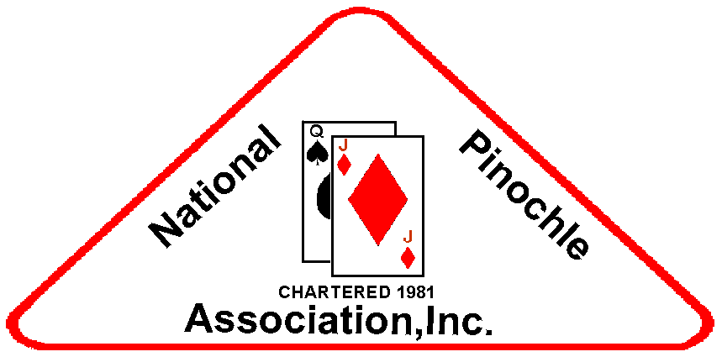 NPA Gazette

August 2014 Vol. XVII, Issue No. 10

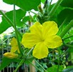    

________________________________________________________________________________________________________________

### **TABLE OF CONTENTS**

**NATIONAL**…………………..……….1

Schedule of Events

**CHAPTERS**………….……………….2

Birthdays/Illness/Death

INSPIRATION……………………….2

LAUGHTER…………………………..2

**CLASSIFIEDS/ADDRESSES…**….3

### **2014 ANNUAL TOURNAMENT & CONVENTION**

### **SCHEDULE OF EVENTS**

*THURSDAY, AUGUST 27, 2014*

12:00 - 12:30 p.m.

--Sponsorship Committee Mtg.

12:30 - 1:00 p.m.

--Rainbow Committee Mtg.

1:00 – 1:30 p.m.

--Fundraising Committee Mtg.

2:00 – 2:30 p.m.

--Regional Representatives

2:30 – 3:00 p.m.

--Research & Ed Committee

3:00 – 3:30 p.m.

--NPA Store Committee

3:30 – 4:30 pm.

--Executive Committee (Closed)

6:00 p.m.

--Seating Mini Tournament

6:30 p.m.

--Mini Tournament

---------------------------------------------------------

*FRIDAY, AUGUST 29, 2014*

9:00 – 9:30 a.m.

--Financial Audit (Closed)

9:20 – 10:00 a.m.

--Tournament Committee

10:00 a.m. - 10:30 a.m.

--Bylaws Committee Meeting

10:30 – 10:50 a.m.

--Membership Committee

10:50 – 11:10 a.m.

--Scholarship Committee Meeting

11:10 a.m. – 1:00 p.m.

**Lunch**

1:00 – 2:00 p.m.

--Treasurer’s & Audit Q&A

--Delegates Sign In

2:00 – 4:00 p.m.

--NPA Board of Directors Meeting

--Hospitality follows Hall of Fame Inductions

4:30 – 5:30 p.m.

--Registration Mini Tournament

6:00 p.m.

--Seating Mini Tournament

6:30 p.m.

--Mini Tournament

*SATURDAY, AUGUST 30, 2014*

7:00 – 8:00 a.m.

--Side Pot registration

8:00 – 8:15 a.m.

--Seating for Main Tournament

8:15 – 8:30 a.m.

--Greetings

8:30 – 8:55 a.m.

--Instructions

8:55 – 9:00 a.m.

--Prayer/NPA Pinochle Anthem

9:00 a.m.

--Main Tournament (15 rounds)

12:30 – 1:45 p.m.

--Lunch

1:50 p.m.

-- Main tournament resumes

*SUNDAY, AUGUST 31, 2014*

7:00 – 8:00 a.m.

--NPA Memorial Service

800 – 8:30 a.m.

--Seating for Tournament Play

9:00 a.m.

--Main Tournament continues

(6 Rounds)

--Awards

### **UPCOMING TOURNAMENTS**

2014 SANCTIONED

Aug. 28-31……………NPA Annual

(Tampa, FL)

Oct. 10-12……………PIPS, Augusta

2014 NON-SANCTIONED

Sept. 19-21……..31-19, Richmond

Oct.31–Nov. 2…...Metro Pinochle

Nov. 7–9….……Tidewater Knucks

Dec. 5-7…………….PIPS, Augusta

### **Happy Birthday to__**

### **Aces Around Pinochle Club**

Phyllis Jenkins – September 7

### **AMPS**

Ernest Tolbert – September 3

### **Augusta Pinochle Club**

Emil Wodicka – September 5

### **Cincinnati Pinochle Club**

Greg Fairbanks – September 16

Donna Pace – September 3

Hayward Thompson – Sept. 6

Patricia Williams – September 4

### **Columbus Bucks & Does**

Ella Murphy – September 19

### **Columbus Pinochle Club**

Rosetta McMurray – Sept. 4

Delores Pressley – Sept.19

### **D C Players Pinochle Club**

Joseph Stroy – September 15

### **Queen City Players**

Norbert Reid – September 30

### **Montgomery Pinochle Pals**

Jimmy Brown – September 20

Gwen Harris – September 11

Margaret Stoudemire – Sept. 20

Thomas Parks – September4

### **PIPS**

Gloria McKinney – Sept. 24

Charlie Vinson – September 28

### **The Cudas Pinochle Club**

Alice Cannon - September

### **West Coast Best**

Maurice Armster – Sept. 11

Bill Fenrich – September 1

### **DEATH**

### **Pinochle Champs**

Letha Martin passed.

### **INSPIRATION**

Fires can’t be made with dead embers, nor can enthusiasm be stirred by spiritless men. Enthu-siasm in our daily work lightens effort and turns even labor into pleasant tasks.

~~~~~~~~~James Baldwin~~~~~~

---------------------------------------------------------

Music enters our bodies, com-mandeering the pulse in our veins, and reminds us that pleasure isn’t a matter of feeling good but of feeling more alive.

~~~~~~~Holly Brubach~~~~~~~~~

Hard work spotlights the character of people: some turn up their sleeves, some turn up their noses, and some don’t turn up at all.

~~~~~~~~~Sam Ewing~~~~~~~~

### **LAUGHTER**

Jokes are for individuals who accept them as they are – humor! Make sure and know who is reading them.

---------------------------------------------------------



A lawyer married a woman who had previously divorced ten husbands. On their wedding nite, she told her new husband, ‘Please be gentle, I’m still a virgin.’ ‘What?’ said the puzzled groom. “How can that be if you

Have been married 10 times?’

‘Well #1 was a sales rep who kept telling me how great it was going to be. #2 was in software services who was never really sure how it was supposed to function, but he said he’d look into it and get back to me. #3 was from field services who said everything checked out diagnos-tically but he just couldn’t get the system up. #4 was in telemark-eting who knew he had the order,

Page 2

he didn’t know when he would be able to deliver. #5 was an engineer who understood the basic process but wanted three years to research, implement, and design a new state-of-the-art method. #6 was from finance and administration who thought he knew how but wasn’t sure whether it was his job or not. #7 was in marketing and though he had a nice product he never was sure how to position it. #8 was a psychologist who was always talking about it. #9 was a gynecologist who only looked at it. #10 was a stamp collector and all he did was… God! I miss him! but now that I’ve married you I’m really excited!’

‘Good,’ said the new husband, ‘but, why?’

‘You’re a lawyer. This time I know I’m gonna get screwed!’

--------------------------------------------------------









### **CLASSIFIEDS**

Looking for the perfect cruise vacation? Contact Val Culpepper of *Hooked on Cruises* at 770-739-7860.

--------------------------------------------------------

Time for the family reunion? Contact JoAnn Ross for a profes-

sional research and presentation of your family tree…404-768-5698 or [www.familytreescharted.com](http://www.familytreescharted.com)

--------------------------------------------------------

If you need professional pictures for any occasion – wedding, reunion, birthday, etc., Taylor Photography can meet your needs. Contact Roosevelt Taylor at 404-758-0717.

--------------------------------------------------------

Vulcan Princess, Inc. -- Screen printing & embroidery -- Contact Frank Turpin: 404-219-3376 or

[tuako3@aol.com](mailto:tuako3@aol.com)

---------------------------------------------------------

Need a caterer for your every need? EDC (Edna’s Delectable Cuisine) is waiting for your call –

404-767-1024 or email

[brownednaw@yahoo.com](mailto:brownednaw@yahoo.com)

--------------------------------------------------------

Learn the game using the teaching tool – ‘Pinochle Mat’ – developed and distributed by an experienced player. Available on Amazon for $35.00 but will sell to NPA members at $25.00. Contact Mrs. Lydia Walker at 305-255-7782 for further info.

### **NPA Website**

All information to be posted on the website should be emailed to [webmaster@npapinochle.org](mailto:webmaster@npapinochle.org).

The web address is:

/http://www.npapinochle2.org/



### **NPA Newsletter**

The Gazette is distributed by the Research and Education Com-mittee of NPA for its members.

News should be forwarded to:

Brenda Stephens

Bstephense@aol.com

5750 Buffington Rd.

Apt. #4202

College Park, GA 30349

404-310-3755 (Cell)

404-565-1352 (Home)